Share the graphics below along with the post copy to help spread the word about the OEMS Health and Safety & Mental Health Libraries.
Post 1: Strength Requires Maintenance
Post Copy: Strength requires maintenance. First responders endure by getting the help they need. Mental health tools are just a few clicks away in the Office of EMS Resource and Research Libraries. Scan the QR codes or visit the URLs for quick access.
Facebook/Instagram Graphic | X/Twitter Graphic
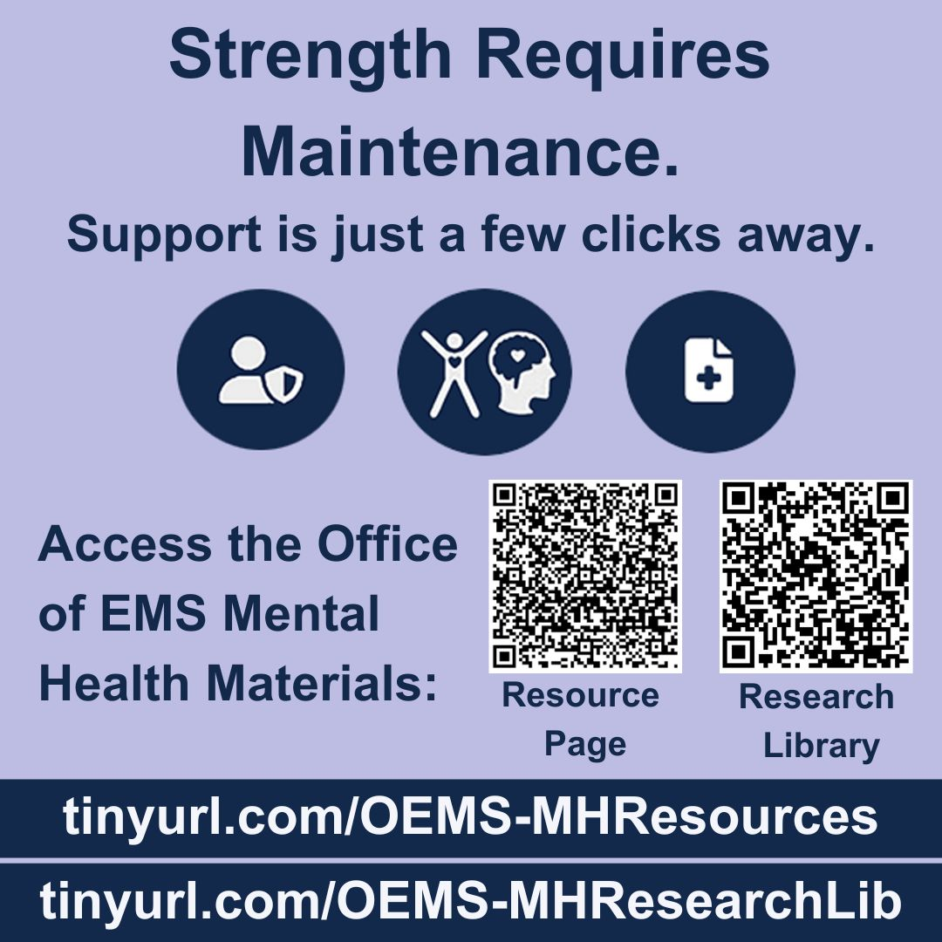 | 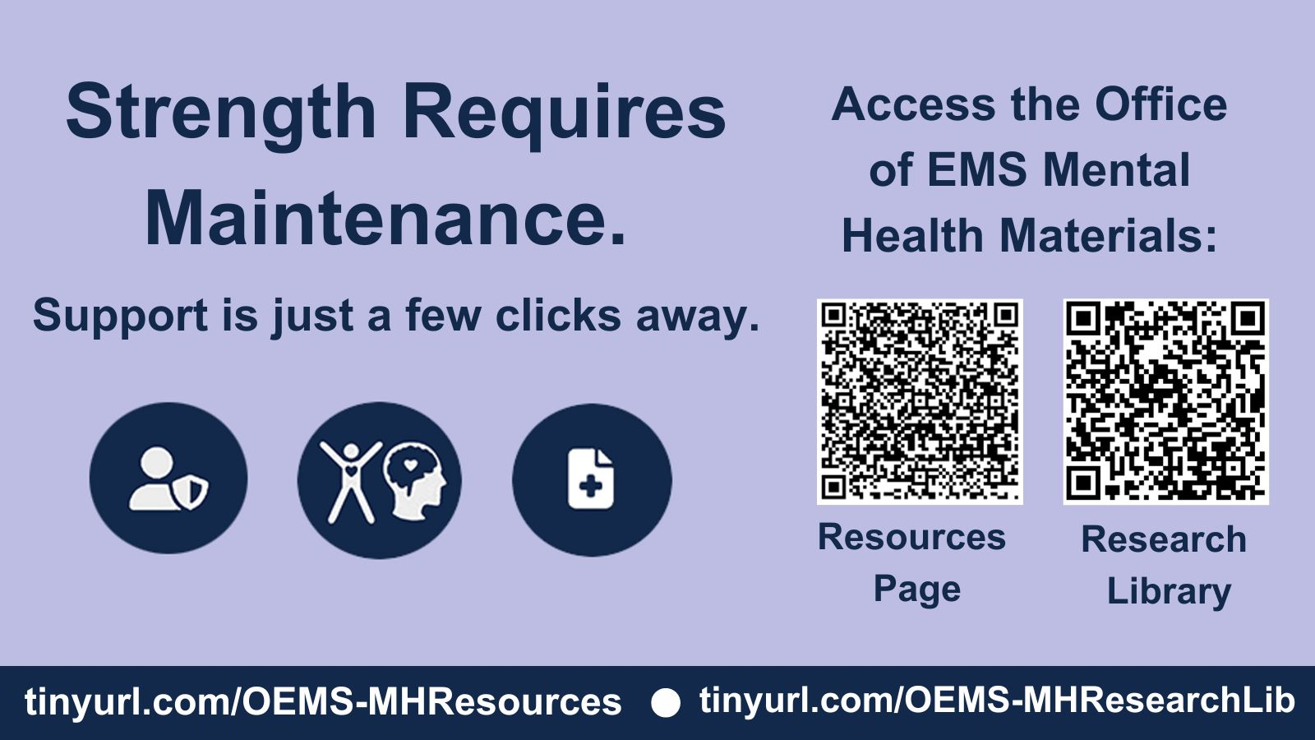

Post 2: Helpers need help sometimes, too.
Post Copy: Everyone needs help at some point, including the helpers. Asking for help can be a hard but important first step to getting better. If you or someone you know needs support, mental health tools are just a few clicks away in the Office of EMS Resource and Research Libraries. Scan the QR codes or visit the URLs for quick access.
Facebook/Instagram Graphic | X/Twitter Graphic
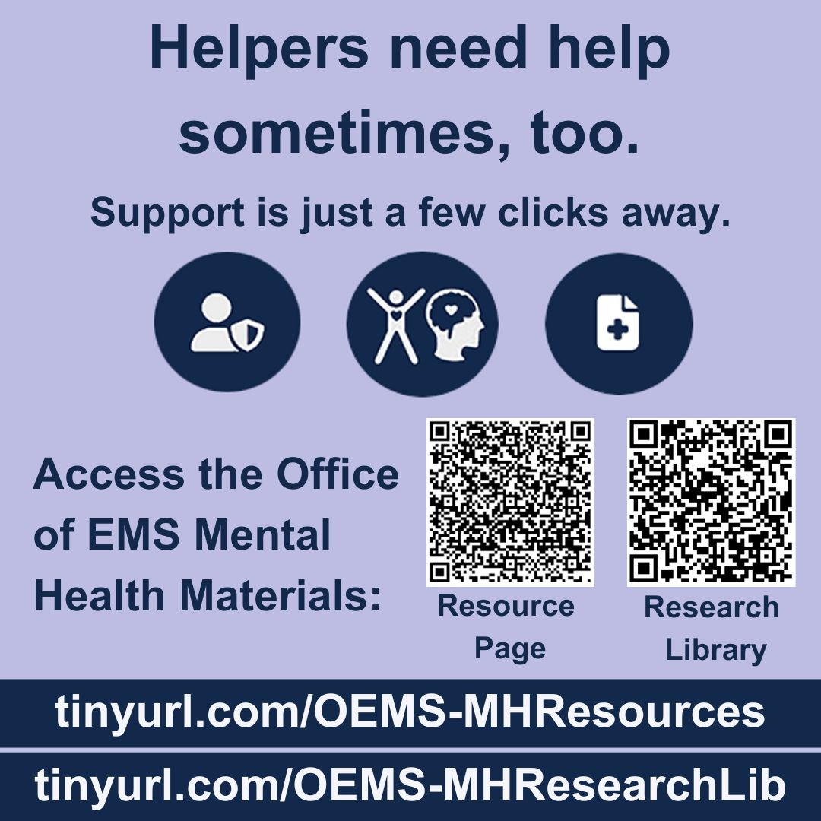 | 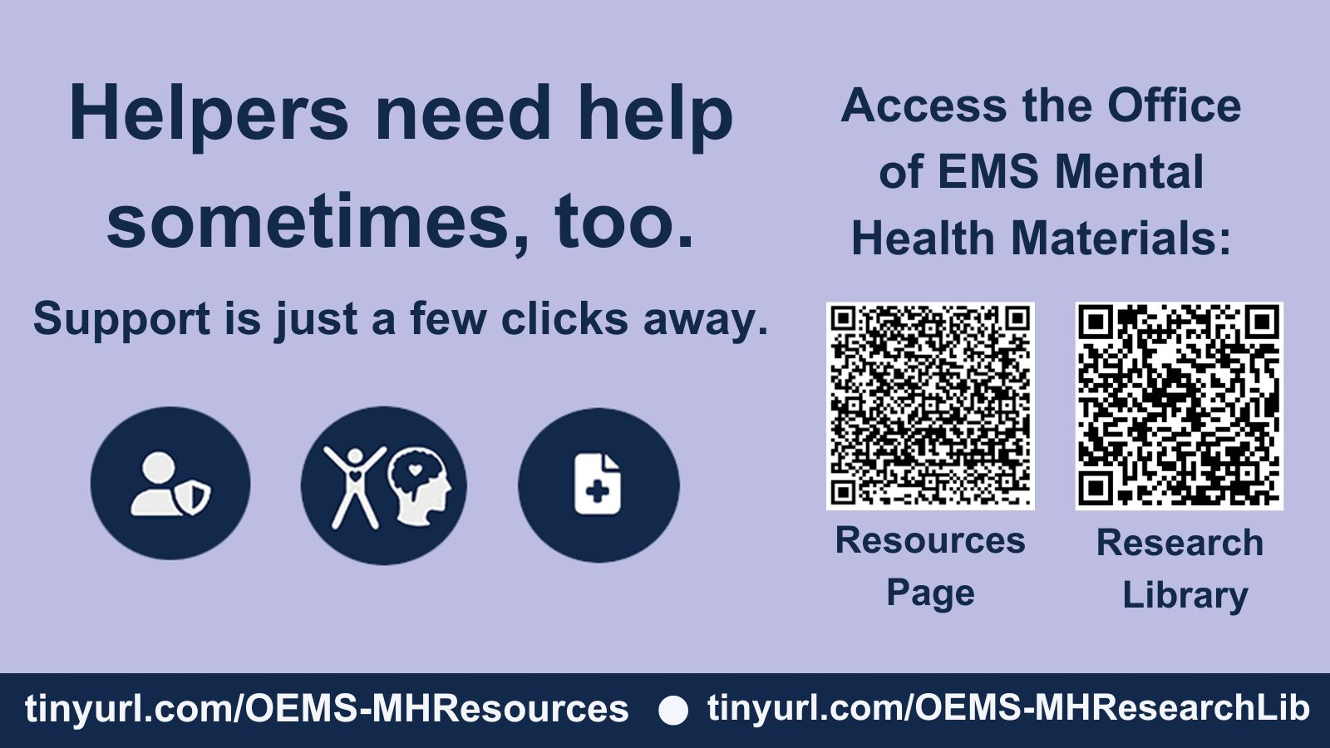

Post 3: Need help now? Know someone who needs help?
Post Copy: First responders know that crises can happen to anyone. If you or someone you know is experiencing a mental health crisis, tools are just a few clicks away in the Office of EMS Resource and Research Libraries. Scan the QR codes or visit the URLs for quick access.
Facebook/Instagram Graphic | X/Twitter Graphic
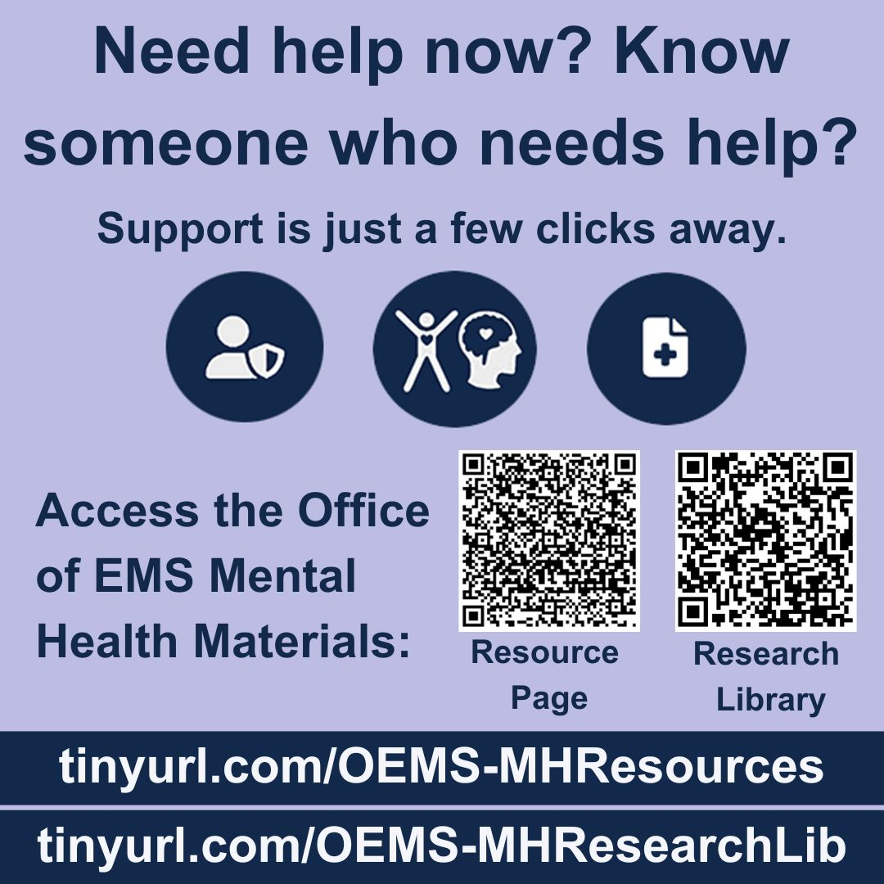 | 